**Instagram Clone (MERN)**

**First Page Login Form**

Instagram form logo

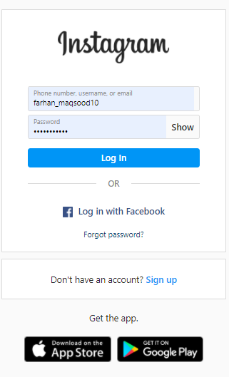

Instagram mobile app link button for android and iOS

Login with facebook and forget password options also sign up options for new users font-Family is used segoe UI

Login form with login button font-family is Segoe UI

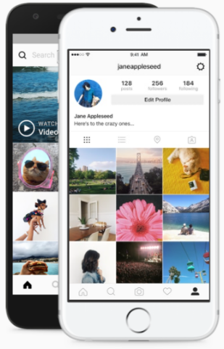

Footer of login form page font-family is used Segoe UI Font-color is gray

Two mobiles pics with animation



**After login**

header



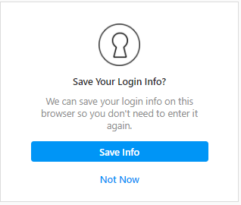

This popup will appear after login insta

This notification popup will appear after save your login information

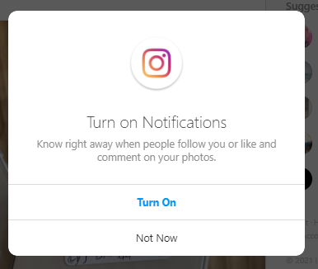

Footer of login form page font-family is used Segoe UI Font-color is gray



**Home Page of Insta**

Header of insta with href links logos and search bar



Status bar

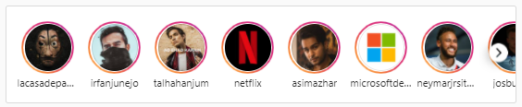

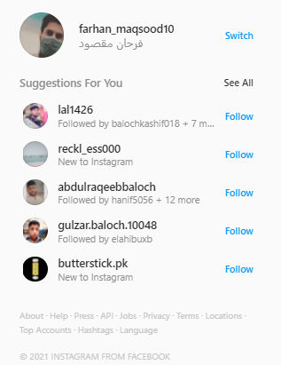

Profile navigation and for you of friends suggestions you can follow them

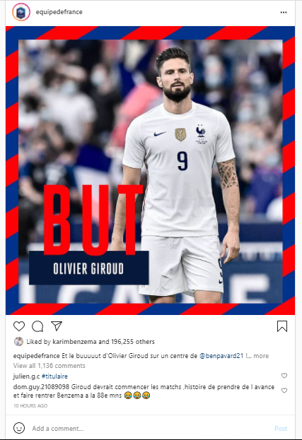

Main page all friends and following peoples posts also you can comment like and share with others you can read comments and see total likes

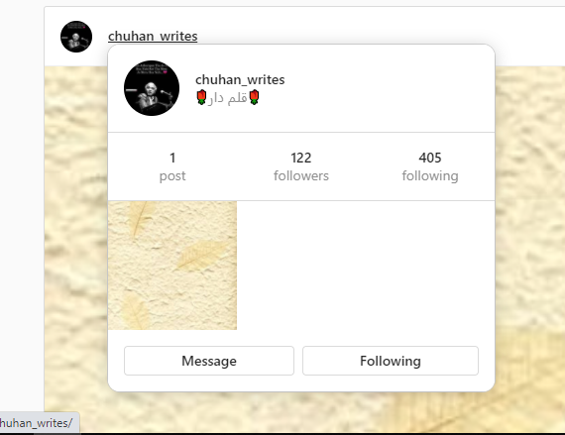

When we click on messenger icon from header this page will appear

after mouse over on any friends id this popup will appear

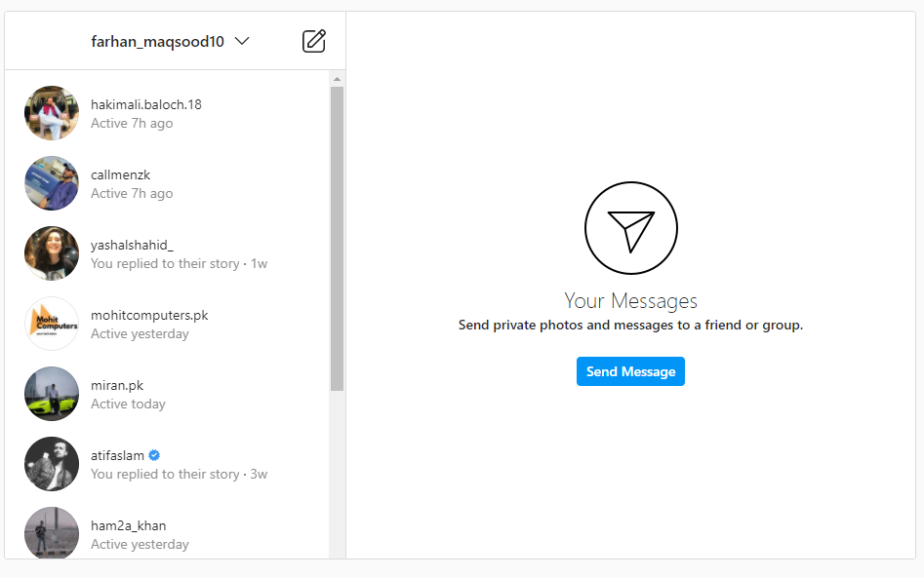

When you click any of your friend DM you can see this

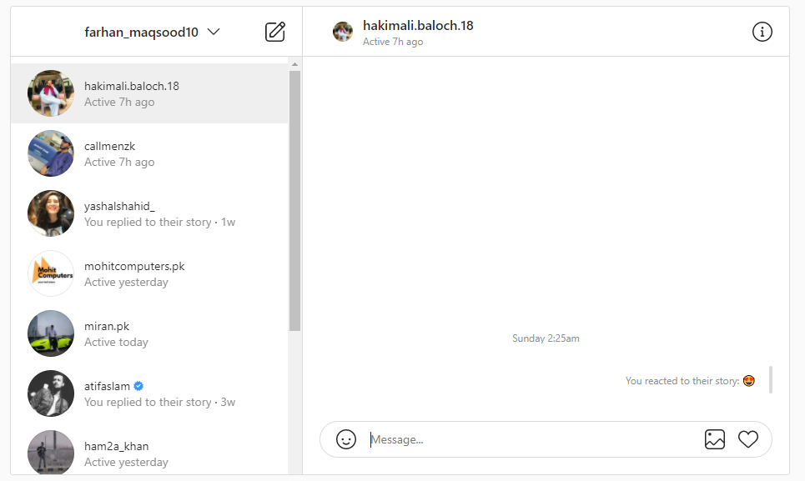



Header of insta with href links logos and search bar

When you click in compass icon on header you will see all insta post randomly



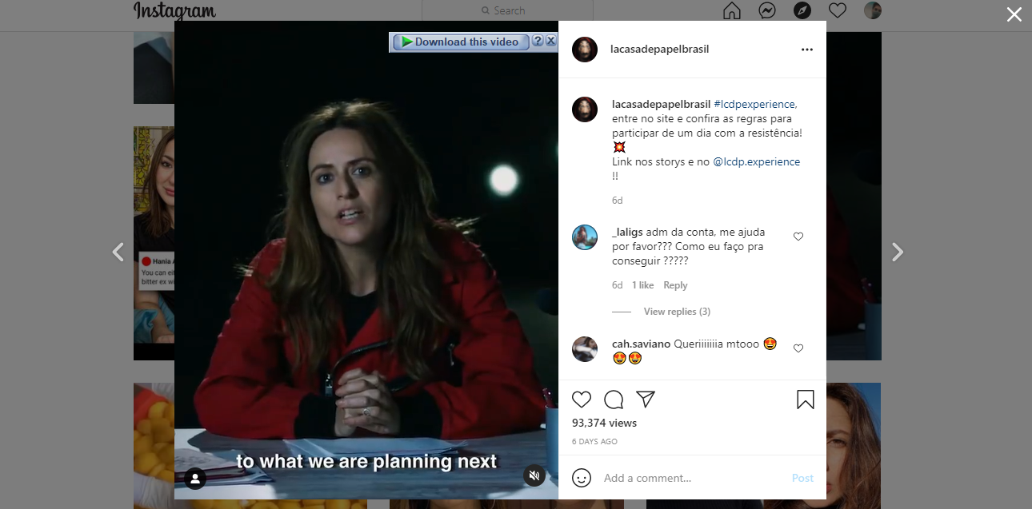

When you click any post on compass page then this view of link appear

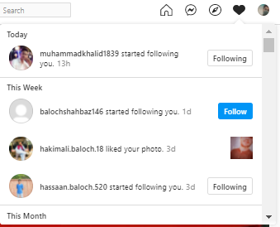

When you click on heart icon on header the notification bar popup will appear here you will see all notification like comments , likes and share

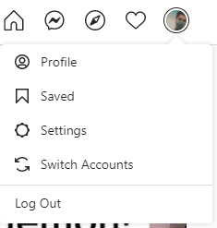

When you click on your profile pic on header bar you will see dropdown of where you can visit different tags

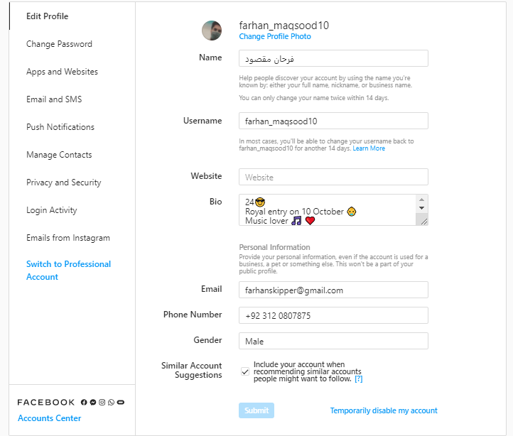

When you click settings you will see this view where you can edit profile and change settings and privacy